PayDollar/PesoPay/SiamPay PayGate
Integration Guide for ECShop 2.7.3

Outline
- Install and configure the module on ECShop
- Setup datafeed URL on PayDollar/PesoPay/SiamPay

Note: This guide assumes that ECShop is already installed on your web server.

Install and configure the module on ECShop

- Upload the paydollar module on your ecshop website using an FTP client.
The PayDollar module includes the following files. Please follow the folder structure:
- /ecshop/includes/module/payment/paydollar.php
- /ecshop/languages/en_us/payment/paydollar.php
- /ecshop/languages/zh_cn/payment/paydollar.php
- /ecshop/languages/zh_tw/payment/paydollar.php
- Login to your ECShop Backend
- Go to Menu > System Setup > Payment. Find PayDollar and click “Install”
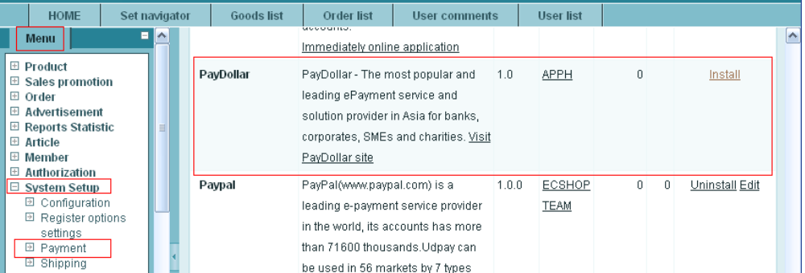
- Configure the PayDollar module
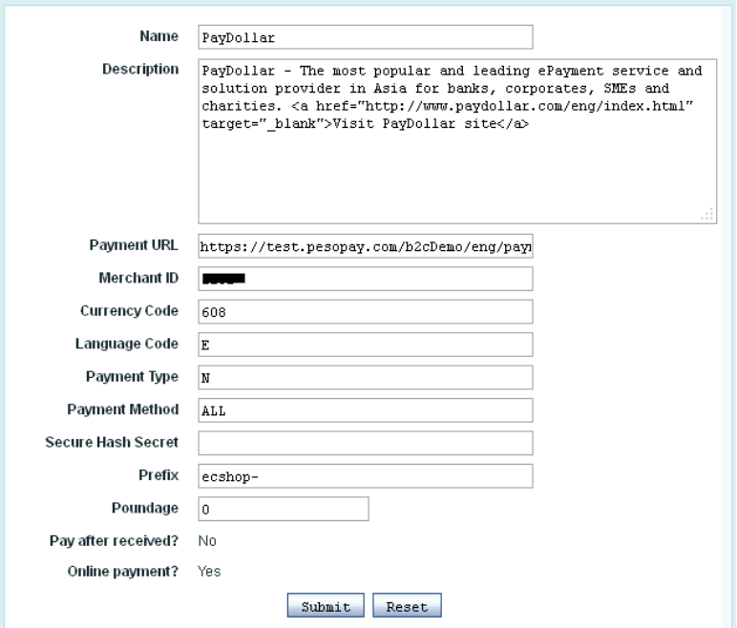

Payment URL: The integration URL to which platform you are to integrate.
PayDollar:
Live: https://www.paydollar.com/b2c2/eng/payment/payForm.jsp
Test: https://test.paydollar.com/b2cDemo/eng/payment/payForm.jsp

PesoPay:
Live: https://www.pesopay.com/b2c2/eng/payment/payForm.jsp
Test: https://test.pesopay.com/b2cDemo/eng/payment/payForm.jsp

SiamPay:
Live: https://www.siampay.com/b2c2/eng/payment/payForm.jsp
Test: https://test.siampay.com/b2cDemo/eng/payment/payForm.jsp

Merchant ID: The merchant account id provided by PayDollar/PesoPay/SiamPay
Currency Code: The currency to be used. Depends on the merchant account
“344” – HKD
“840” – USD
“702” – SGD
“156” – CNY (RMB)
“392” – JPY
“901” – TWD
“036” – AUD
“978” – EUR
“826” – GBP
“124” – CAD
“446” – MOP
“608” – PHP
“764” – THB
“458” – MYR
“360” – IDR
“410” – KRW
“682” – SAR
“554” – NZD
“784” – AED
“096” – BND
“704” – VND
“356” – INR
Language Code: The language of the payment page
“C” – Traditional Chinese
“E” – English
“X” – Simplified Chinese
“K” – Korean
“J” – Japanese
“T” – Thai
“F” – French
“G” – German
“R” – Russian
“S” – Spanish
Payment Type: If you prefer N (Sale) or H (Authorize) – Depends on the merchant account
Payment Method: The payment method to display on the payment page. - Depends on the merchant account
“ALL” – All the available payment method on the Merchant Account
“CC” – Credit Card Payment
“VISA” – Visa Payment
“Master” – MasterCard Payment
“JCB” – JCB Payment
“AMEX” – AMEX Payment
“Diners” – Diners Club Payment
“PPS” – PayDollar PPS Payment
“PAYPAL” – PayPal By PayDollar Payment
“CHINAPAY” – China UnionPay By PayDollar Payment
“ALIPAY” – ALIPAY By PayDollar Payment
“TENPAY” – TENPAY BY PayDollar Payment
“99BILL” – 99BILL BY PayDollar Payment
“MEPS” – MEPS BY PayDollar Payment
“SCB” –SCB (SCB Easy) BY PayDollar Payment
“BPM” –Bill Payment BY PayDollar Payment
“KTB” –Krung thai Bank (KTB Online) BY PayDollar Payment
“UOB” –United Oversea bank BY PayDollar Payment
“KRUNGSRIONLINE” –Bank of Ayudhya (KRUNGSRIONLINE) BY PayDollar Payment
“TMB” –TMB Bank BY PayDollar Payment
“IBANKING” –Bangkok Bank iBanking BY PayDollar Payment
“UPOP” – UPOP BY PayDollar Payment
Secure Hash Secret: Optional. The secret key for the secure hash functionality – Please check with PayDollar/PesoPay/SiamPay.
Prefix: Optional. Prefix for Order Reference No.

Setup the Datafeed URL on PayDollar/PesoPay/SiamPay

1. Login to your PayDollar/PesoPay/SiamPay account.
- PayDollar
  - Live: https://www.paydollar.com/b2c2/eng/merchant/index.jsp
  - Test: https://test.paydollar.com/b2cDemo/eng/merchant/index.jsp
- PesoPay
  - Live: https://www.pesopay.com/b2c2/eng/merchant/index.jsp
  - Test: https://test.pesopay.com/b2cDemo/eng/merchant/index.jsp
- SiamPay
  - Live: https://www.siampay.com/b2c2/eng/merchant/index.jsp
  - Test: https://test.siampay.com/b2cDemo/eng/merchant/index.jsp

2. After login, Go to left sidebar on Profile > Profile Settings > Payment Options.
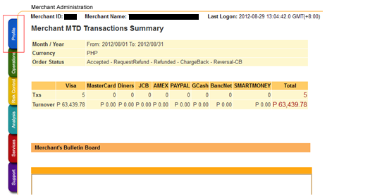

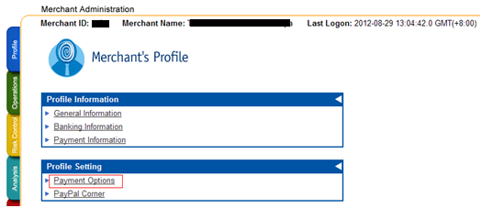
3. Click the “Enable” radio and set the datafeed URL on “Return Value Link” and click the “Update” button.
The datafeed URL should be like this: http://www.yourdomain.com/respond.php?code=paydollar
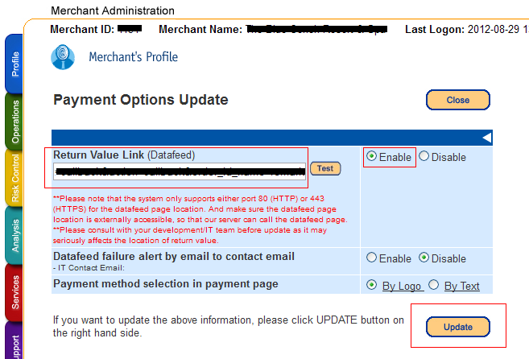

4. On the confirmation page, review your changes then click the “Confirm button”.
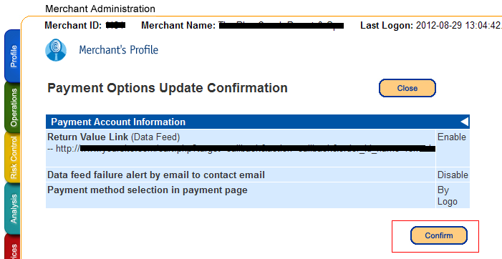

5. The datafeed URL has been set.
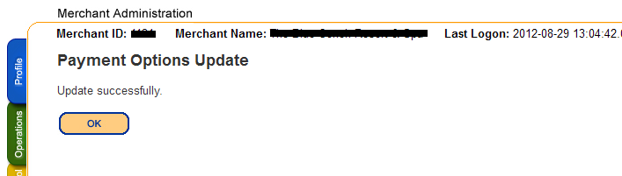

The End

